**Adjusting the Original Image and Testing With Different Noise Types**

Originally, when I divided by the Frobenius noise, I got black boxes because the pixel values were so small. I multiplied by 255 and converted to uint8 and the following images are what happened as a result. I’m not sure this normalized the images as much as made them lighter, but the noise levels are more comparable and the lightness seem to be the same. I also adjusted the speckle variance, salt density, and gaussian variance to all be .3, which seem to be relatively comparable visually. The results seem to be more consistent as well. For some reason, using the imnoise() function with poisson noise did not seem to change the image.

Original:



Normalized:



Speckle:

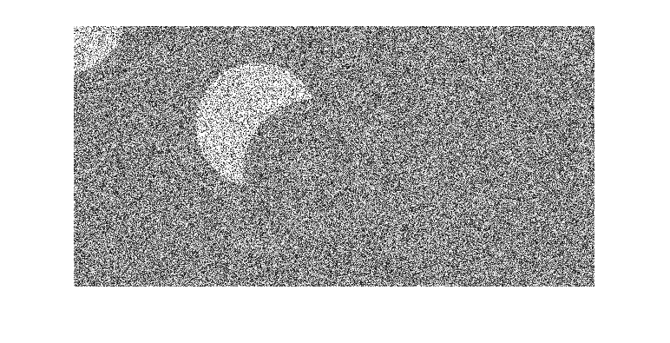

Salt:

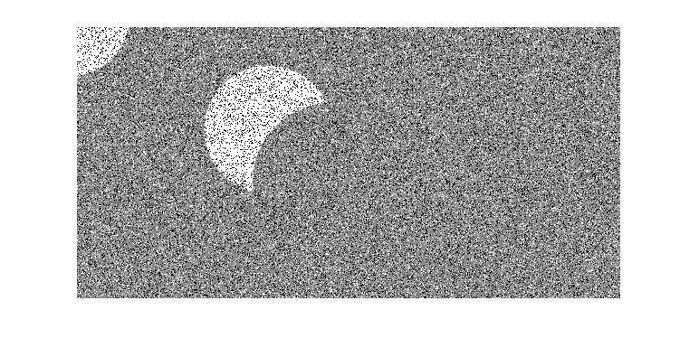

Gaus:

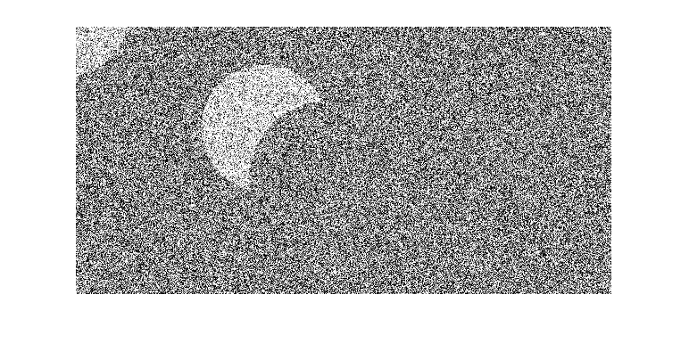

Pois:



A comparison of the 3 rounds:

Round 1: Non normalized images (speck var 1,salt .2, gaus var .1)

Round 2: Normalized by multiplying Frobenius norm of speckle image (speck var 1,salt .2, gaus var .1)

Round 3: Current (speck var .3,salt .3, gaus var .3)